

**Registration 2023/24**

* **Registration form** – Please complete one form per family.   
  List each child and each lesson/group.
* **Academic calendar** – Your instructor will confirm your lesson dates directly with you. The KCMS office follows the School District 23 calendar (on the reverse).  
  Visit our website for current calendar items.

**Registration Fees**:

|  |  |
| --- | --- |
| **Annual Private Lessons for 1 student** | **$50.00** |
| **Annual Private Lessons for 2 or more students from the same family** | **$80.00** |
| Private Lessons for 1 student after January 2024 | $25.00 |
| Private Lessons for 2 or more students from the same family after January | $40.00 |

*Note: Registration Fees for private lessons are pro-rated on January 1st and April 1st*

*Note: Paid Summer Registration Fees will be credited towards your Annual Registration Fees*

**Registration Process**:

1. Confirm all lesson times for each student with your instructor(s).
2. Review our KCMS Policies and Safety Plan on our website.
3. Complete the Registration form attached or [use our fillable form online.](https://www.kelownacommunitymusicschool.ca/_files/ugd/b24a12_376595cd2c484108a714daa535fdae2f.pdf)   
   List ALL students and ALL lessons on one form. **ONE FORM PER FAMILY.**
4. Save Registration Form as **PDF**. Print and bring in, or **email** to: [kelownacommunitymusicschool@shaw.ca](mailto:kelownacommunitymusicschool@shaw.ca)
5. Registration Fees (amount listed above) Pay via **cash, debit, cheque or etransfer** upon registration.  **INCLUDE STUDENTS NAME IN THE NOTE OF ETRANSFER** Send to:[kelownacommunitymusicschool@shaw.ca](mailto:kelownacommunitymusicschool@shaw.ca)
6. Once processed, you will receive an onboarding email with your invoice, and the KCMS Policies and Consent Form link. Completing this form ensures you have read our policies.

*Your spot is not guaranteed until the registration fees have been paid and you have completed the KCMS Policies and Consent Form.*

Office hours: Monday 9am-5pm; Tues-Thurs 1-5pm

250-860-1737

Please phone prior to visiting to confirm summer office hours.

Win Back Your Registration Fee!!

**All families who have paid their annual Registration Fee by 4:30pm, Thursday, July 14th**

**will be entered into a draw to win back their registration fees!**

*(Credit will be applied against annual fees for 2023/24. No cash value.)*

**PLEASE CONFIRM YOUR START DATE WITH EACH TEACHER.**

*The office is not responsible for scheduling. Please confirm your schedule directly with your teacher.*

Email: [kelownacommunitymusicschool@shaw.ca](mailto:kelownacommunitymusicschool@shaw.ca) or visit us online at [www.kelownacommunitymusicschool.ca](http://www.kelownacommunitymusicschool.ca)

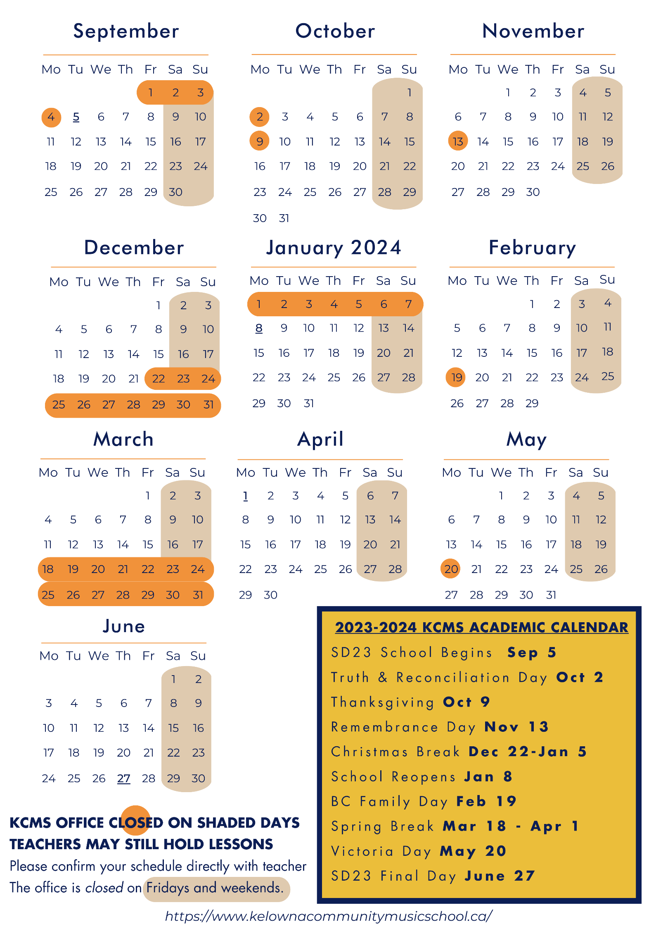

**REGISTRATION 2023/2024**

Please complete all areas below.

*Information will be forwarded to teachers and used for student records and school administration purposes.*

|  |  |  |  |  |  |  |  |  |  |  |  |  |  |  |  |  |  |  |
| --- | --- | --- | --- | --- | --- | --- | --- | --- | --- | --- | --- | --- | --- | --- | --- | --- | --- | --- |
| **CONTACT INFORMATION NEW RETURNING** | | | | | | | | |  | | | | | | | | | |
| **Parent/Guardian Name or Adult Student Name** | | | | | | | | | **Relationship to Student (if applicable)** | | | | | | | | | |
|  | | | | | | | | |  | | | | | | | | | |
| **Mailing Address – Street** | | | | | | | | | **City** | | | | | | **Postal Code** | | | |
|  | | | | | | | | |  | | | | | |  | | | |
| **Phone 1** |  | | | **Phone 2** |  | | | | **Email** | |  | | | | | | | |
| **Medical condition(s) of concern?** | | | | **Yes No** | | | **Emerg Contact** | |  | | | | | | | | | |
| **If Yes, please advise:** | |  | | | | | **Email:** | |  | | | | | | | | | |
|  | | | | | | | **Phone:** | |  | | | | | | | | | |
| **I would like to receive the KCMS Newsletter by email Already Received** | | | | | | | | | | | | | | | | | | |
| **I would like to be a KCMS Member - Members have the right to vote at our Annual General Meeting each fall. $10 fee** *Help KCMS by becoming a member!* | | | | | | | | | | | | | | | | | | |
| **LESSON INFORMATION** | | | | | | | | | | | | | | **Office Use Only** | | | | |
| **Student**  **full name** | | | **DOB**  **yy/mm/dd** | **Instrument**  **Group Program** | | | **Teacher** | | | **Length & Day of Week** | | **First Lesson** | | **Last Lesson** | | | **Total  # of weeks** |
|  | | |  |  | | |  | | |  | |  | |  | | |  |
|  | | |  |  | | |  | | |  | |  | |  | | |  |
|  | | |  |  | | |  | | |  | |  | |  | | |  |
|  | | |  |  | | |  | | |  | |  | |  | | |  |
|  | | |  |  | | |  | | |  | |  | |  | | |  |
|  | | |  |  | | |  | | |  | |  | |  | | |  |
|  | | |  |  | | |  | | |  | |  | |  | | |  |
|  | | |  |  | | |  | | |  | |  | |  | | |  |
| **Important: I understand ALL schedules must be confirmed with each teacher.**  **I understand I will be receiving a KCMS Policies and Consent Form to complete when I receive my invoice.** | | | | | | | | | | | | | | | | | | |
|  | | | | | | |  | | | | | | | | | | | |
| **---------------------------------------------** | | | | | | | **----------------------------------------------------- -----------------------** | | | | | | | | | | | |
| **Print Name (Parent/Guardian/Adult Student)** | | | | | | | **Signature (Parent/Guardian/Adult Student) Date** | | | | | | | | | | | |
| **Registration forms can be dropped off or emailed to:** [**kelownacommunitymusicschool@shaw.ca**](mailto:kelownacommunitymusicschool@shaw.ca) | | | | | | | | | | | | | | | | | | |
| **FOR OFFICE USE ONLY** | | | | | | | | | | | | | | | | | | |
|  | | | | | | | | | | | | | | | | | | |
| **Fees** | | | **# of Lessons** | **Price Total** | | **Payment Total** | | **Invoiced in Sage** | | | | | **Sage Payment**  **J#** | | | **In File Maker** | |
| ***Registration*** | | |  |  | |  | |  | | | | |  | | |  | |
|  | | |  |  | |  | |  | | | | |  | | |  | |
|  | | |  |  | |  | |  | | | | |  | | |  | |
|  | | |  |  | |  | |  | | | | |  | | |  | |
|  | | |  |  | |  | |  | | | | |  | | |  | |
|  | | |  |  | |  | |  | | | | |  | | |  | |
|  | | |  |  | |  | |  | | | | |  | | |  | |
|  | | |  |  | |  | |  | | | | |  | | |  | |